**Detection of Signals and Lanes for Self Driving Cars**

**Problem Statement**

The problem ofRoad Lane Detection and signal detection is to find out the lane and traffic signs automatically for self driving cars. It is all due to the advancement in computer vision and deep learning that it become possible to detect road track from video’s frames and to detect traffic signs during the process of the self-driving. In this research the car combines YOLO version 1 for the object detection, polynomial regression with thresholding as the road lane guidance, and a controller that manages the information between those two systems. The proposed methods can be used for object detection, object position detection (left, front, or right), steering suggestion, and road lane’s guidance. But there are various challenges involved like variability in vehicle shape, safety of the car, over lighting, sharp-turned roads, and collision warning, and different road environments. The detection of an Object, identification of an Object in real time is a major concern. A prominent example of a safety failure is the 2016 Tesla auto-pilot accident, where the sensors of the vehicle were blended by the sun and the system failed to recognize the truck coming from the right, leading to the crash.

**Background Work**

Despite of the challenges given in the problem statement self driving car is still an active area of research. Numerous approaches have been proposed over the years. In traditional systems Road Lane Detection is one of the main concern in the application of many self-driving car engineers. There are many approaches that can be used for the edge detection to help the road lane detection: Sobel, Laplacian, and Canny detectors. Sobel edge detection takes advantage of gradient magnitude with the greatest rate’s change in the light intensity. The Canny detector however, goes one step further by applying the Gaussian filter and the Non-Maximum Suppression (NMS) and thresholds the range under such circumstances, robust lane recognition in the adverse weather is required. Lane or road detection related research mainly uses vision sensors.

Recently sensor based study showed to divide the image into five zones, finds the vanishing point in each zone, and expresses the steep curve and the continuous curve with the vanishing points is also been seen which fuse with other sensors to increase the recognition rate of the lane. Researchers conducted self-driving by using a camera and a laser to determine the travelable area of t he vehicle, but the laser was not used for lane detection.

**Methodology**

1. **Data Collection and Dataset Preparation**: This will involve collection of images from various sources and formatting them, annotating them with ground truth object bounding boxes
2. ***Developing a CNN based pedestrian detection model****:* Popular pretrained CNN feature extraction models such as YOLO pretrained on ImageNet dataset is used for this task.  *Road Lane Detection*. After the object detection work done by Yolo, road lane detectionis

done which consist of 4 main parts: warping, filtering, detecting the road lane, and de-

warping.

1. **Deployment and analysis on real life scenario**: The model developed is deployed for further analysis where both positive and negative cases will be used for further improvement in methodology.

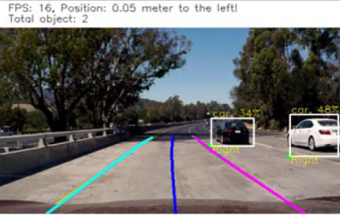

Model Development

Self Driving Car Model

Object Detection& Road Lane Detection

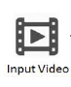

**Input Image Output**

Video Dataset

Figure 1: Architecture of Plant Disease Detection System

**Experimental Design**

**Dataset**: Self driving car dataset is from ImageNet.

**Evaluation Measures**: Measures such as accuracy and Mean Average Precision (MAP) will be computed by comparing the detected bounding boxes and ground truth boxes from the datasets.

**Software and Hardware Requirements**: *Python* programming language andCUDA,16 GB ofRAM, and NVIDIA GTX 1070 GPU 8 GB.